1. R Project-Prepare a dataset related to your own project and perform k-Means, k-Medians, Expectation Maximisation (EM), Hierarchical Clustering and report the results.

.

**Description and Screenshots:**

K means:

Here we use the K means clustering algorithm on the data set of iris. We couldn’t do the clustering yet on our data set as we dint have the variety of data yet but we could collect the algorithms and test it on the iris data set. I have attached the code and the screenshot below:

> iris3 <- iris

> iris2$Species <- NULL

> (kmeans.result <- kmeans(iris2, 3))

> plot(iris2[c("Petal.Length", "Petal.Width")], col = kmeans.result$cluster)

> points(kmeans.result$centers[,c("Petal.Length", "Petall.Width")], col = 1:3, + pch = 8, cex=2)

So this clustering takes place based on the parametrs of the species like petal length ad sepal length which groups the sample by which we can define a particular species for it based on the observation. This is a general protocol for unsupervised learning.

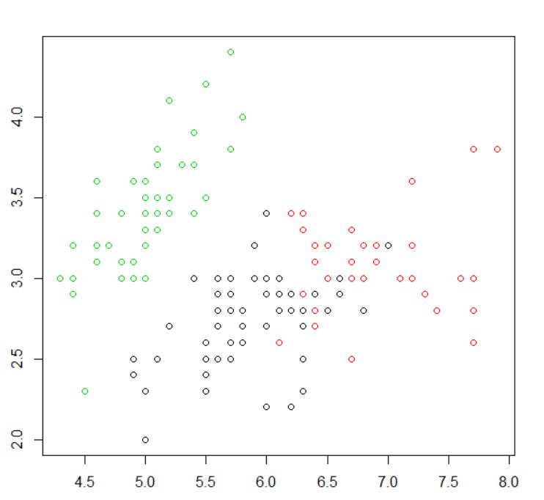

Kmedians:

K medians is similar to k means just that here medians are considered instead of mean. Medians tend to be more effective in terms of the prediction as it tries to eliminate the outliers which mean considers. The outliers effect the prediction by a lot.

Here below are the results of the k medians .

> library(fpc)

> pamk.result <- pamk(iris2)

> # number of clusters

> pamk.result$nc

> # check clustering against actual species

> table(pamk.result$pamobject$clustering, iris$Species)

> layout(matrix(c(1,2),1,2)) # 2 graphs per page

> plot(pamk.result$pamobject)

> layout(matrix(1))

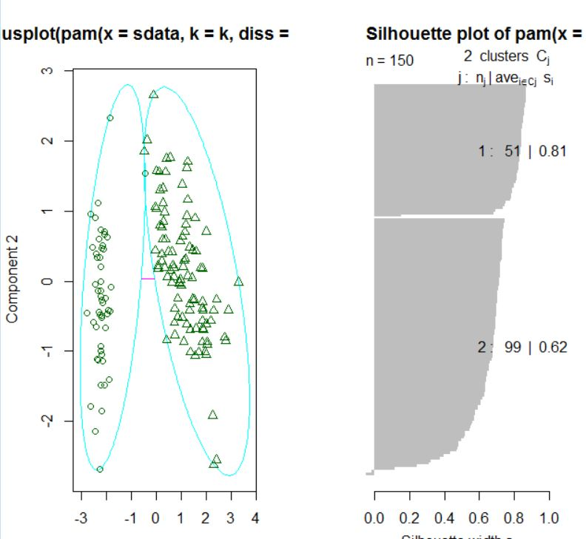

Hierarchical Clustering

In Hierarchical Clustering we use the same clustering methods however we have two different statergies to adapt to the cluster differences. It s done in a greedy method.

Strategies for hierarchical clustering generally fall into two types:[[1]](https://en.wikipedia.org/wiki/Hierarchical_clustering" \l "cite_note-1)

* **Agglomerative**: This is a "bottom up" approach: each observation starts in its own cluster, and pairs of clusters are merged as one moves up the hierarchy.
* **Divisive**: This is a "top down" approach: all observations start in one cluster, and splits are performed recursively as one moves down the hierarchy.

> layout(matrix(c(1,2),1,2))

> plot(pamk.result$pamobject)

> q()

> idx <- sample(1:dim(iris)[1], 40)

> irisSample <- iris[idx,]

> irisSample$Species <- NULL

> hc <- hclust(dist(irisSample), method="ave")

> plot(hc, hang = -1, labels=iris$Species[idx]

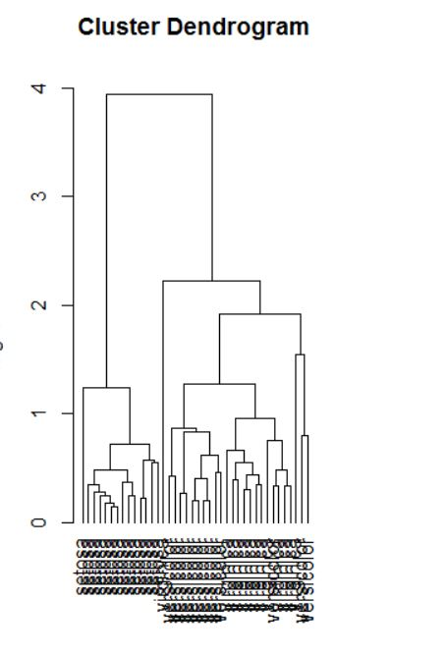

Expectation Maximization:

Expectation Maximization:

-----------------------------------------------

library(mclust) # load mclust library

x1 = runif(20) # generate 20 random random numbers for x axis (1st class)

y1 = runif(20) # generate 20 random random numbers for y axis (1st class)

x2 = runif(20) # generate 20 random random numbers for x axis (2nd class)

y2 = runif(20) # generate 20 random random numbers for y axis (2nd class)

rx = range(x1,x2) # get the axis x range

ry = range(y1,y2) # get the axis y range

plot(x1, y1, xlim=rx, ylim=ry) # plot the first class points

points(x2, y2 ) # plot the second class points

mix = matrix(nrow=40, ncol=2) # create a dataframe matrix

mix[,1] = c(x1, x2) # insert first class points into the matrix

mix[,2] = c(y1, y2) # insert second class points into the matrix

mixclust = Mclust(mix) # initialize EM with hierarchical clustering, execute BIC and EM

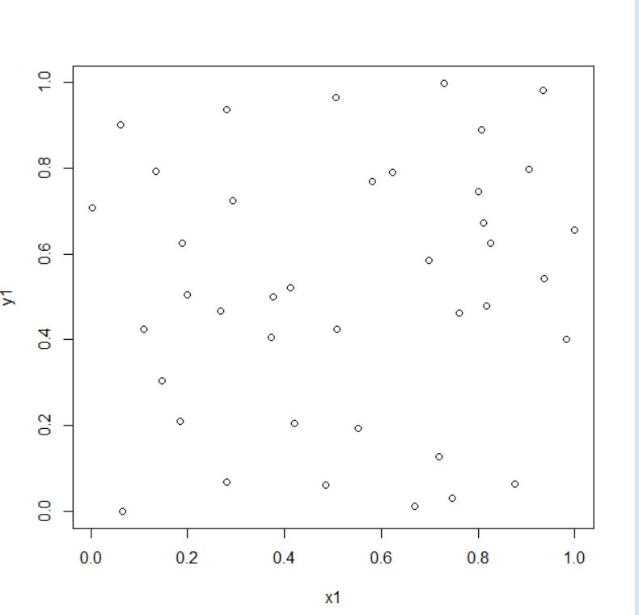

1. Watch Application-Data collection related to your own project through Smart Phone and Watch, send notifications to watch using intuitive data analysis.

**Description**: My project is related to monitoring the health of the person. I tried to determine the heartbeat of the person using the sensors in my smartphone and sent it as a notification to his/her relatives through their smart watches.

**Screenshots:**

**